Working with Lambda & Lambda Block

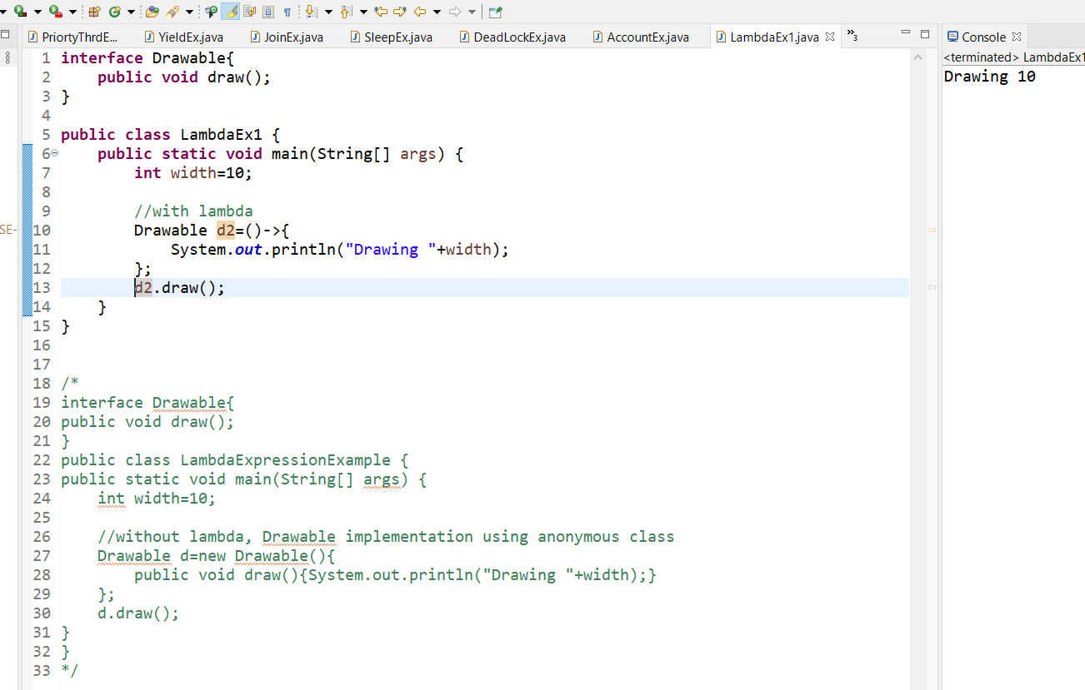

Create a Runnable interface and apply lamda expression.

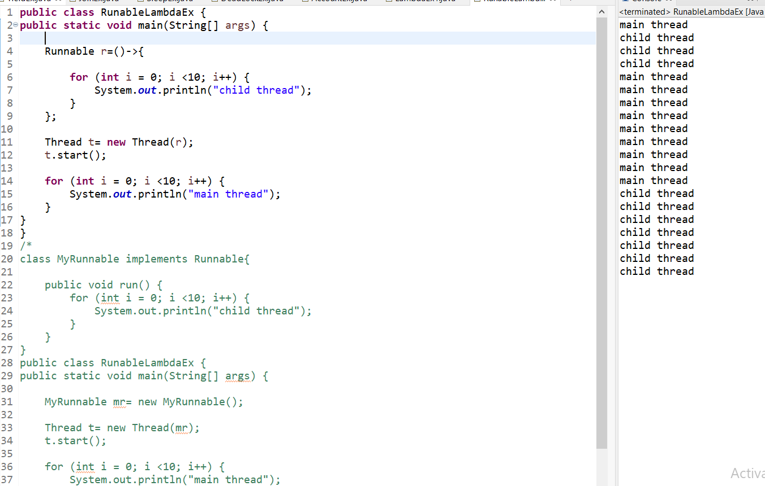

Create a class SqureRoot apply lamdaexpreesions.

Create a class with addition method with parameters.

Create a ArrayList class add values apply lamda expression

Take predicate functional interface test given value even number or not.

Take predicate functional interface test length of the given name is greater than 6 or not?

Create a employee class with ArrayList class add key value pair name,salary, findout salary>7000?

